Node
Introduction to npm
(Node Package Manager)

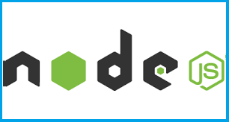

Version 1.0

Amendment Record Sheet

Version No. | Date | Amendment Description | Amended By | Approved By
1.0 | 1 Feb 2017 | Approved document | Gerry Byrne | David Wilson
1.1 | 26 Feb 2017 | Amended some wording | Gerry Byrne | David Wilson

Topic Overview

This topic will introduce you to Node Package Manager (npm). Node Package Manager makes it easy for JavaScript developers to share code, reuse code and to update code that is being shared.

Node.js makes it possible to write applications in JavaScript on the server and since it is built on the V8 JavaScript runtime and written in C++ it is fast. Originally, it was intended as a server environment for applications, but then developers started using it to create tools to aid them in local task automation. Since then, a whole new ecosystem of Node-based tools (such as Webpack, Grunt and Gulp) has evolved to transform the face of front-end development.

To make use of these tools (or packages) in Node.js we need to be able to install and manage them in a useful way. This is where npm, the Node Package Manager, comes in. npm allows us to install the packages we want to use and provides us with a useful interface to work with them. Before we can start using npm we first have to install Node.js on our system.

Topic Objectives

At the end of this topic you will be able to:
- Install Node on a computer
- Understand the role of Node Package Manager
- Use Node Package Manager to install packages
- Understand where Node Package Manager installs the packages
- Understand the difference between locla and global installation of packages
- Install the webpack package locally and globally
- Installing specific versions of packages
- Install package updates
- Manage npm cache
- Managing package dependencies

Contents

Node Package Manager 6
Installing Node.js 10
Exercise – Installing Node.js on Windows 10
Exercise – Initialising our project 16
Exercise – Listing Global Packages 18
Exercise – Listing Local Packages 19
Exercise – Installing Packages Globally 21
Exercise – Installing Packages Locally 23
Exercise – Uninstalling Local Packages 26
Exercise – Installing Specific Versions of Packages 27
Exercise – Updating a Package 28
Exercise – Managing Cache 29
Exercise – Managing Dependencies 31
References: 32

Node Package Manager

Node Package Manager

Node.js has very powerful package management system built into it. The Node Package Manager (npm) tool comes as a default with every Node.js installation. The purpose of NPM modules is quite simple, they are a set of publicly available, reusable components, available through a simple installation by means of an online repository, with version and dependency management.

The full list of packaged modules can be found on the NPM website https://npmjs.org/, or accessed using the NPM CLI tool that automatically gets installed with Node.js. The module ecosystem is open to all, and anyone can publish their own module that will be listed in the NPM repository.
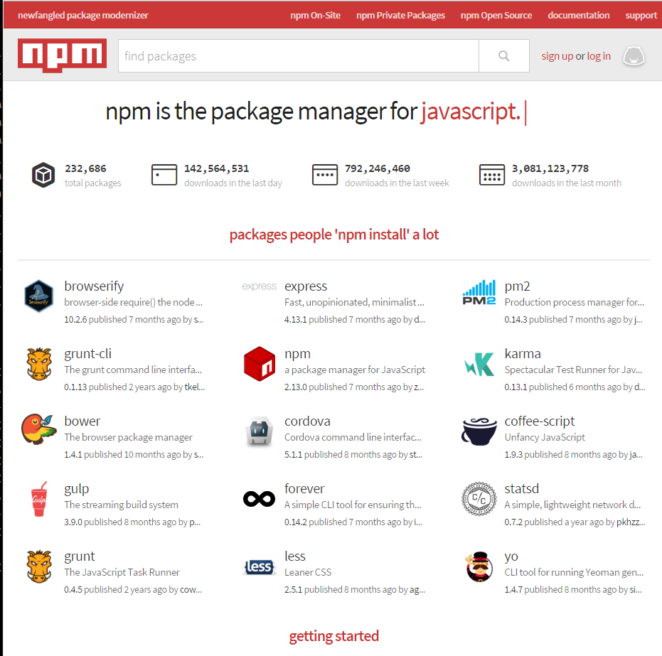
Currently (February 2016) some of the most popular NPM modules today are:
express | Express.js is a Sinatra-inspired web development framework for Node.js, and is the de-facto standard for the majority of Node.js applications. Express is a minimal and flexible Node.js web application framework that provides a robust set of features for web and mobile applications.
connect | Connect is an extensible HTTP server framework for Node.js, providing a collection of high performance “plugins” known as middleware. Connect serves as a base foundation for Express.
socket.io and  sockjs | Server-side component of the two most common websockets components out there today. Socket.IO enables real-time bidirectional event-based communication. It works on every platform, browser or device, focusing equally on reliability and speed.
Jade | Jade is one of the popular templating engines, inspired by HAML, a default in Express.js. Jade is designed primarily for server side templating in node.js, however it can be used in many other environments. It is only intended to produce XML like documents (HTML, RSS etc.) so don't use it to create plain text/markdown/CSS/whatever documents.
mongo and  mongojs | MongoDB wrappers to provide the API for MongoDB object databases in Node.js.
redis | Redis client library. Redis is an open source (BSD licensed), in-memory data structure store, used as database, cache and message broker. It supports data structures such as strings, hashes, lists, sets, sorted sets with range queries, bitmaps, hyperlog logs and geospatial indexes with radius queries.
coffee-script | CoffeeScript is a little language that compiles into JavaScript. Underneath that awkward Java-esque veneer, JavaScript has always had a good core and CoffeeScript is an attempt to expose the good parts of JavaScript in a simple way.  The golden rule of CoffeeScript is: "It's just JavaScript". The code compiles one-to-one into the equivalent JS, and there is no interpretation at runtime. You can use any existing JavaScript library seamlessly from CoffeeScript (and vice-versa). The compiled output is readable and pretty-printed, will work in every JavaScript runtime, and tends to run as fast, as or faster than the equivalent handwritten JavaScript.
underscore  (lodash, lazy) | The most popular utility library in JavaScript, packaged to be used with Node.js, as well as its two counterparts, which promise better performance by taking a slightly different implementation approach.  Underscore.js provides lots of small functions to help you use JavaScript as a functional programming language. Besides the actual functions it provides, it can also be great for learning more JavaScript as it provides an annotated version of its source code and it also allows us to use it both as a Node.js module and in the browser.
forever | Probably the most common utility for ensuring that a given node script runs continuously. Keeps your Node.js process up in production in the face of any unexpected failures.

Node Installation

Installing Node.js

Exercise – Installing Node.js on Windows
- Open the browser of your choice.
- In the address bar enter the following:
https://nodejs.org/en/

- Press the Enter key.

The home page will appear

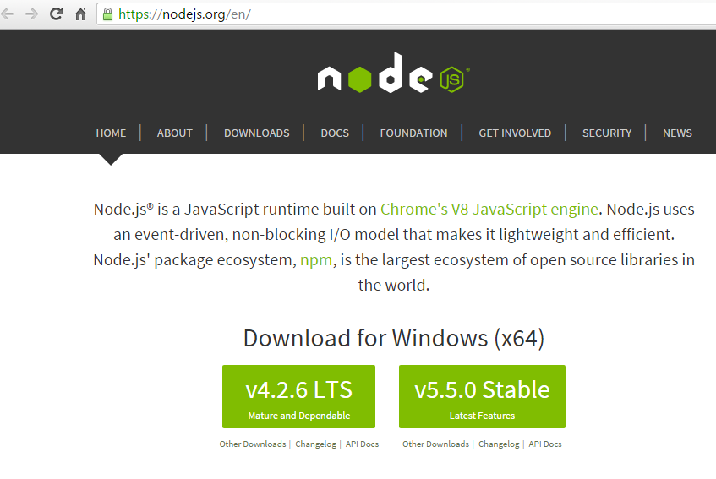

- Click on the Downloads tab.
- Choose the version of Node that you wish to install.

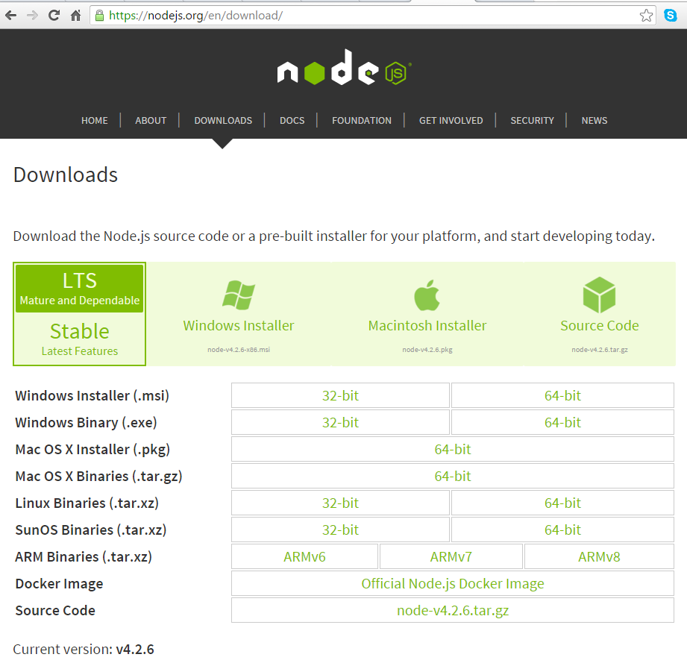

- Open the download compressed file (e.g. node-v4.2.6-x64.msi).

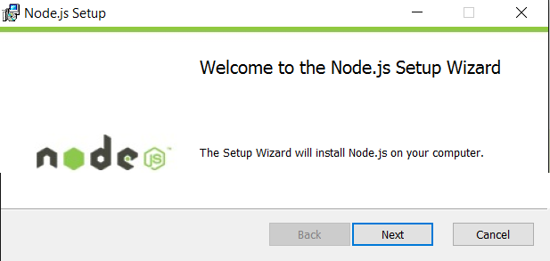

- Click the Next button.
- Accept the agreement.
- Select the location where you want to install the Node.js application e.g. c:\NodeJS.
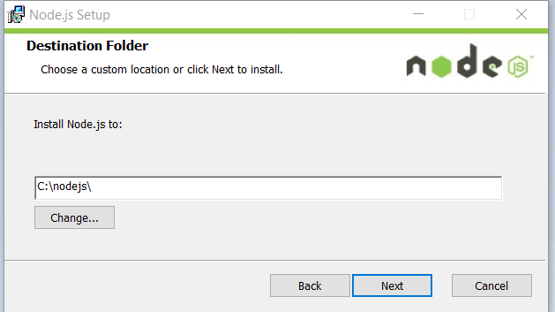

- Click the next button.
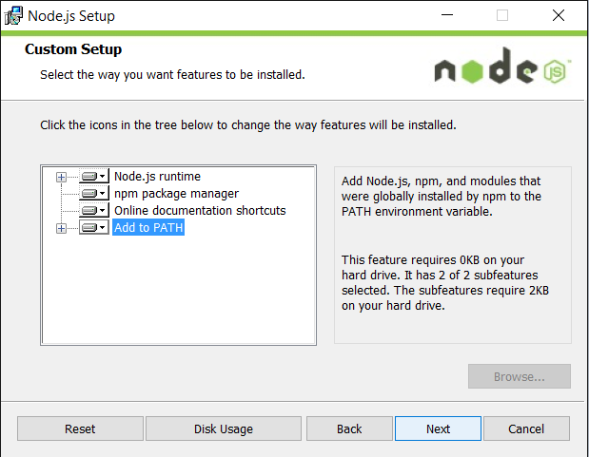

- Click on the Install button.
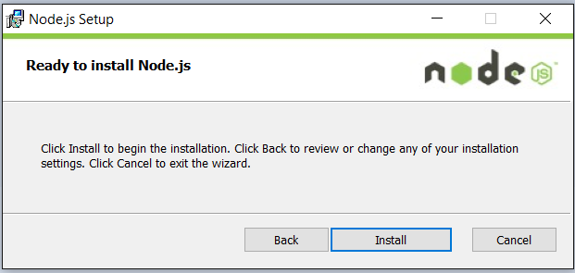

The Node.js application will now install.

- If you are asked to give permission for the installation click the Yes button.

When the Node.js application has been installed the following screen will appear.

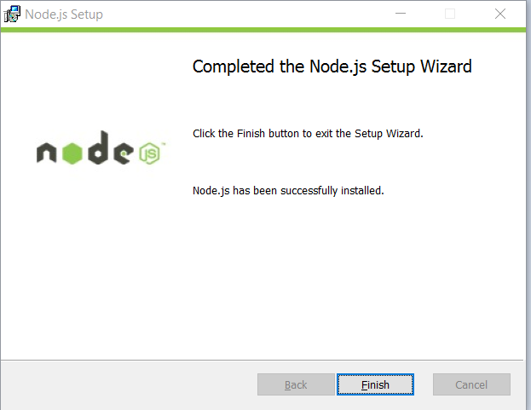

Checking the installation

- Enter the following command at the terminal prompt:

which node

- Press the Enter key.
- Enter the following command at the terminal prompt:

node --version

- Press the Enter key.
- Look at the output that is displayed. It should be something similar to the following:

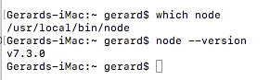

Let us now see that Node has been installed correctly
- Enter the following command at the terminal prompt:

node

- Press the Enter key.
- A > prompt should be displayed.
- Enter the following command at the prompt:

console.log(‘This message shows that Node is running’);

- Press the Enter key.
- Look at the output that is displayed. It should be something similar to the following:

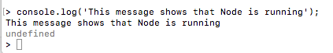

- Enter the following command at the prompt:

.help;

- Press the Enter key.
- Look at the output that is displayed. It should be something similar to the following:

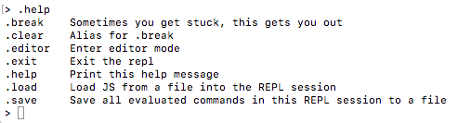

If this all works as expected Node is installed correctly. Now we can concentrate on the Node Package Manager (npm).

Exercise – Initialising our project

We need to create a directory for our project and we will also initiliase Node Package Manager (npm).

- Open a Terminal window.
- Navigate to the location where you wish to create your project e.g.
cd /Users (then press Enter)
cd /gerard (then press Enter)
cd Desktop (then press Enter)

- Enter the following command at the terminal prompt:

mkdir reactproject && cd reactproject

- Press the Enter key.
- Enter the following command at the terminal prompt:

ls (dir)

- Press the Enter key.
- The display will show there are no files just the directory.
- Enter the following command at the terminal prompt:

npm init

- Press the Enter key.

The display will show a message from mpm telling you about the setting up of a package.json file

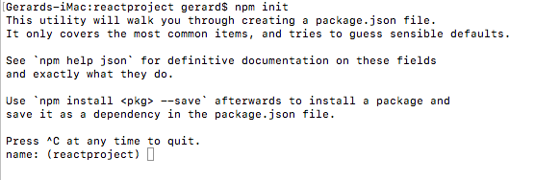.
- For the name type reactproject.
- Press the Enter key.
- For the version Press the Enter key.
- For the description type my first react project
- Press the Enter key.
- For the entry point type index.js or simply press the Enter key.
- Press the Enter key.
- For the test command simply press the Enter key.
- For the git repository simply press the Enter key.
- For the keywords type react first project.
- Press the Enter key.
- For the author type Gerry Byrne.
- Press the Enter key.
- For the licence simply press the Enter key.
- For the question Is this ok? (yes) simply press the Enter key.
- Enter the following command at the terminal prompt:

ls (dir)

- Press the Enter key.
- The display will show there is one file in the directory – package.json.

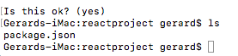

Exercise – Listing Global Packages

We can list the global packages that we have installed using the npm command npm list.

- Open a Terminal window.
- Enter the following command at the terminal prompt:

npm list --global

- Press the Enter key.
- The display will show what the global packages are called and give further detail about the package.

We can list the global packages without the detail using the npm command npm list –g --depth=0.

- Open a Terminal window.
- Enter the following command at the terminal prompt:

npm list –g --depth=0 (npm list –g -depth=0)

- Press the Enter key.
- The display will show what the packages are called with their version number and no further details.

Exercise – Listing Local Packages

We can list the local packages that we have installed using the npm command npm list. Installing packages locally is achieved by leaving out the –global flag in the npm install command.

- Open a Terminal window.
- Enter the following command at the terminal prompt:

npm list

- Press the Enter key.
- The display will show what the local packages are called.

Exercise – Using Node Package Manager

- Enter the following command at the terminal prompt:

which npm

- Press the Enter key.
- Enter the following command at the terminal prompt:

npm --version

- Press the Enter key.
- Look at the output that is displayed. It should be something similar to the following:

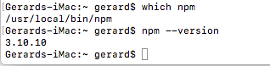

Node Packaged Modules

When we use npm it can install the packages in one of two modes:
- local
In local mode it installs the package in a node_modules folder in your parent working directory. This location is owned by the current user.

global mode (-g attribute)
Global packages are installed in {prefix}/lib/node_modules/ which is owned by root (where {prefix} is usually /usr/ or /usr/local).
This means you would have to use sudo to install packages globally. On certain computers or networks the use of sudo could cause permission errors when resolving third-party dependencies. Equally it could be a security concern.

Exercise – Installing Packages Globally
- Enter the following command at the terminal prompt:

npm install packagename --global

where package name is the name of the node package you wish to install e.g. webpack, express.
In our case we will enter:

npm install webpack --global
(You may need to enter sudo npm install webpack)

- Press the Enter key.
- Look at the output that is displayed. It should be something similar to the following:

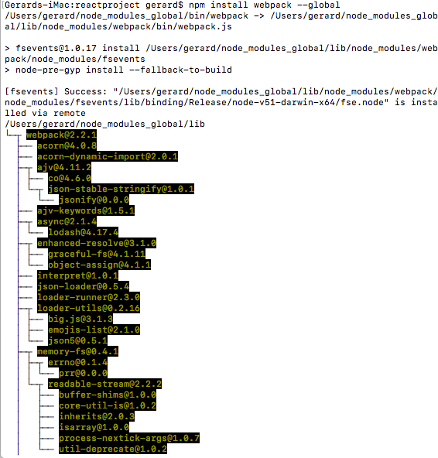
This gives us information about our installation.
Now it’s important to get the current global location.
- Enter the following command at the terminal prompt:

npm config get prefix

- Press the Enter key.
- Look at the output that is displayed. It should be something similar to the following:

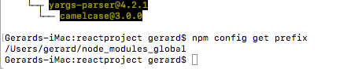
This is the prefix for the global packages.

Exercise – Installing Packages Locally
- Navigate to the location where you created your project.

- Enter the following command at the terminal prompt:

npm install packagename

where package name is the name of the node package you wish to install e.g. webpack, express.
In our case we will enter:

npm install webpack
(You may need to enter sudo npm install webpack)

- Press the Enter key.
- Look at the output that is displayed. It should be something similar to the following:

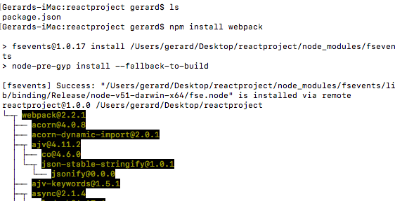

This gives us information about our installation.
- Enter the following command at the terminal prompt:

ls (dir)

- Press the Enter key.
- Look at the output that is displayed. It should be something similar to the following showing us that the folder node_modules has been created:

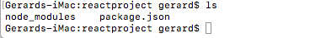

- Enter the following command at the terminal prompt:

ls node_modules dir node_modules

- Press the Enter key.
- Look at the output that is displayed. It should be something similar to the following showing us the materials that have been added to our node modules. We should see webpack:

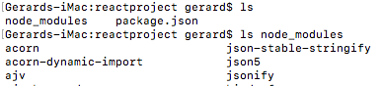
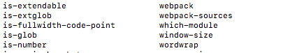

- Enter the following command at the terminal prompt:

npm list

- Press the Enter key.
- Look at the output that is displayed. It should be something similar to the following showing us the the locally installed packages. We should certainly see webpack:

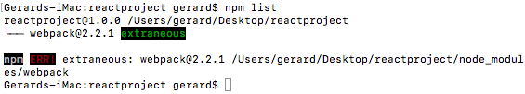

Exercise – Uninstalling Local Packages
- Navigate to the location where you created your project.

- Enter the following command at the terminal prompt:

npm uninstall packagename

where package name is the name of the node package you wish to install e.g. webpack, express.
In our case we will enter:

npm uninstall webpack
(You may need to enter sudo npm uninstall webpack)

- Press the Enter key.
- Look at the output that is displayed. It should be something similar to the following:

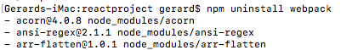

- Enter the following command at the terminal prompt:

ls node_modules (dir node_modules)

- Press the Enter key.
- Look at the output that is displayed. It should be something similar to the following showing us the package has been removed from our node modules. We should not see webpack:

Exercise – Installing Specific Versions of Packages
We can install any package in the version we want using a very simple concatenation to or normal install command. We use the @ sign to append a version number.

- Navigate to the location where you created your project.

- Enter the following command at the terminal prompt:

npm install packagename@versionnumber

where package name is the name of the node package you wish to install e.g. webpack, express and versionnumber is the specific version of the package we wish to install. Using the command npm view webpack versions we will be presented with all the version numbers that exist.

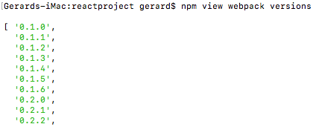

In our case we might wish to enter:

npm install webpack@0.2.2
(You may need to enter sudo npm install webpack@0.2.2 )

Exercise – Updating a Package
We can easily install an updated version of our package.

- Navigate to the location where you created your project.

- Enter the following command at the terminal prompt:

npm update packagename

In our case we will enter:

npm update webpack
(You may need to enter sudo npm update webpack)

- Press the Enter key.
- Look at the output that is displayed. It should be something similar to the following:

- Enter the following command at the terminal prompt:

npm webpack --version

- Press the Enter key.
- Look at the output that is displayed. It should be something similar to the following showing us the package version number:

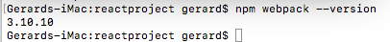

Exercise – Managing Cache
When we use Node Package Manager (npm) to install a package it will keep a copy, so the next time we want to install the package Node Package Manager does not need to look outside the local drive. This speeds up the installation process and avoids network taffic. The copies made by Node Package Manager are cached in the .npm directory in our home path.

- Navigate to the location where you created your project.

- Enter the following command at the terminal prompt:

ls ~/.npm dir c:\users\gbyrn\Appdata\Roaming\npm

- Press the Enter key.
- Look at the output that is displayed. It should be something similar to the following:

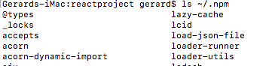

This directory will get untidy with old packages as time goes on. It is important to do some ‘house-keeping’ occasionally in order to clear the directory of these duplicates.

- Enter the following command at the terminal prompt:

npm cache clean

- Press the Enter key.
- Enter the following command again at the terminal prompt:

ls ~/.npm dir c:\users\gbyrn\Appdata\Roaming\npm
- Press the Enter key.
- Look at the output that is displayed. It should be something similar to the following showing us the package version number:

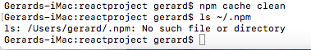

Exercise – Managing Dependencies
Currently, as we are only beginning to build our application, we only have one packages installed in our project directory. As time goes on we will probably install other packages and we will want to inform the package.json file what dependencies exist.

- Navigate to the location where you created your project.

- Open the package.json file in the editor of your choice.

- Amend the code as shown below to add the dependency for webpack. Additional dependencies are added by including a comma followed by the dependency:
{
"name": "reactproject",
"version": "1.0.0",
"description": "my first react project",
"main": "index.js",
"dependencies": {
"webpack": "^3.10.10"
},
"scripts": {
"test": "echo \"Error: no test specified\" && exit 1"
},
"keywords": [
"react",
"first",
"project"
],
"author": "Gerry Byrne",
"license": "ISC"
}

References:

http://www.toptal.com/nodejs/why-the-hell-would-i-use-node-js

